**Raj Singh: COSC 4353 Software Design**

**Complete Project with Demo**

**GROUP 10: Satya Sai Sribhashyam, Tasneem Patel, Jenish Bhadola**

**1. Provide link to GitHub repository for TAs to view the code.(5 points)**

[**https://github.com/Jnbhadol/Project_Group10**](https://github.com/Jnbhadol/Project_Group10)

**2. Rerun the code coverage report. Code coverage must be above 80%. (2 points)**

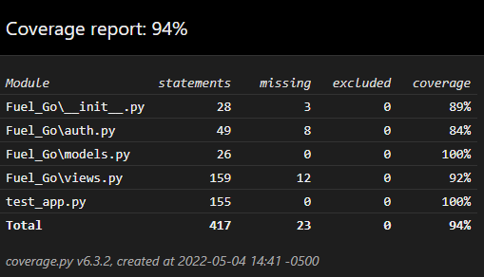

**3. Demo prior to project due date. (3 points)**

Demo done on May 4th 12:15 - 12:30pm with TA Naeem.

**4. IMPORTANT: list who did what within the group. TAs should be able to validate in GitHub, otherwise team members who didn't contribute will receive a ZERO.**

**Fill in this table, provide as much details possible:**

|  |  |  |
| --- | --- | --- |
| **Group Member Name** | **What is your contribution?** | **Discussion Notes** |
| **Tasneem Patel** | Backend coding, unit testing, Database, generated and inserted Hash  Password, Frontend HTML pages | * Did backend coding for the HTML pages (login, registration, profile, fuel quote), added test cases for pricing function and any new validations and functionalities * Created database for all the required pages (user login, profile, quote), and inserted hash password in database. * Created HTML pages for login, registration, and profile pages |
| **Satya Sai Sribhashyam** | Updated HTML pages for frontend to backend, debugging, CSS styling and formatting, designing DB schema, displaying DB to quote history, READM file | * Updated all the front end pages so that backend receives data from front-end and we can access data   through requests.   * Worked on styling and formatting of all the pages, fixed hover buttons in CSS file. * Worked on a README.md file and edited the html pages and added a new file in the assignment folder * Designed DB   schema, and displayed info from DB to history page. |
| **Jenish Bhadola** | Frontend HTML pages, CSS styling and formatting, unit testing, code coverage, fixed any backend issues, pricing function implementation | * Assisted in front end by creating html pages .i.e., Homepage, About Us, Assignments, View Profile along with creating fuel quote and history pages. * Added other functionalities and improvements to nav bar, website logo, page logo, header, footer and other general styling. * Assisted in unit testing, code coverage, backend and also implemented the pricing function. |